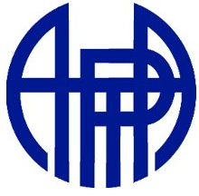
Northern California/ Nevada Section of the American Association of Physics Teachers

attended the Spring meeting of the
Northern California/ Nevada section of the America Association of Physics Teachers
on April 23rd, 2011
at the Exploratorium Museum of San Francisco
www.NCNAAPT.org
Secretary@NCNAAPT.org

